Kick Start my Chart

Assignment # 1

The following charts and data analyze information about 4K plus projects from the crowdfunding service Kickstart. The analyses will be used to determine which projects were most successful and which projects were not.

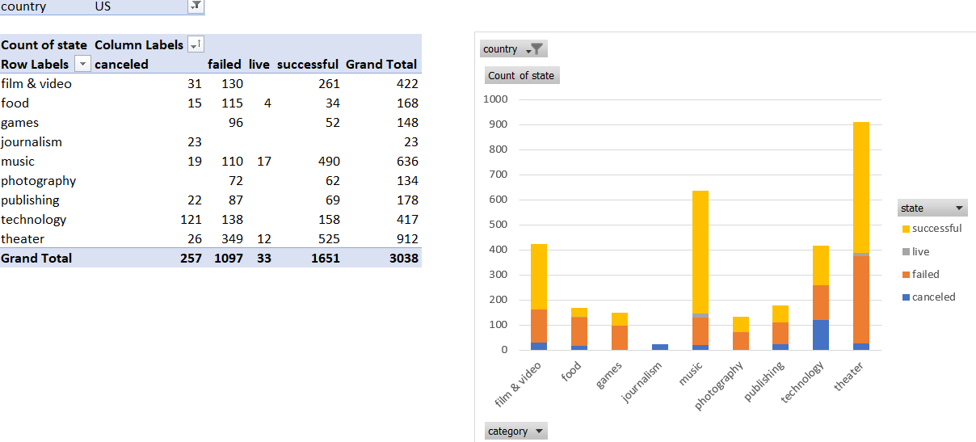

The first set of data is an analysis of projects identified by nine categories. A little over half of all the projects have proven to be successful. Charting the data shows that three categories have proven to be the most successful. They are Film & Video, Music, and Theater. Technology has shown to have as many projects as Film & Video, but is definitely less successful.

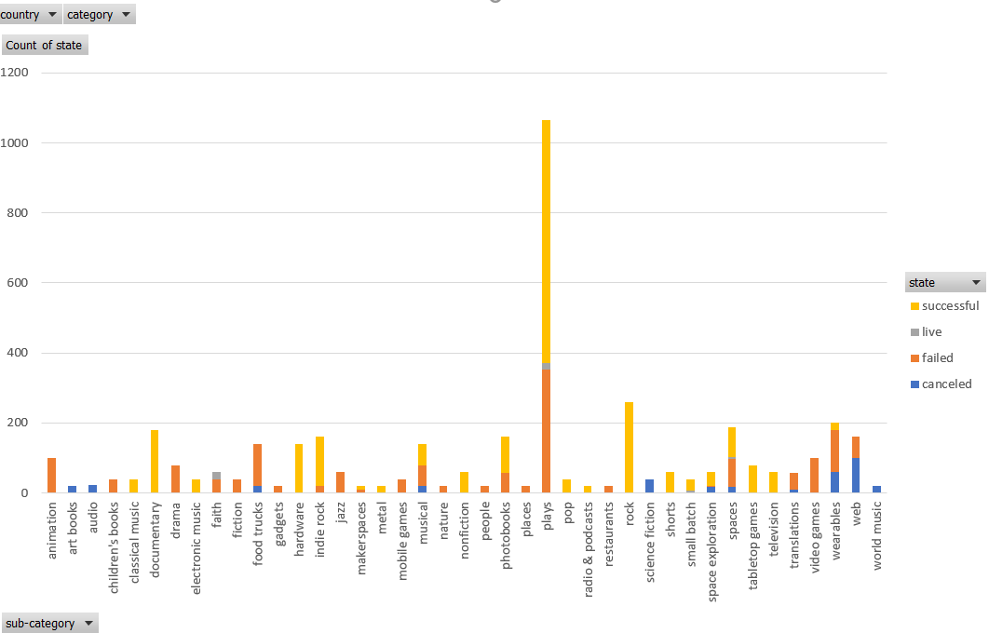

This chart breaks down the nine categories into subcategories. Plays have the most successful projects, but there are quite a few subcategories which have 100% success rates. One wonders if the Theater category should have been broken down into more categories than Plays. There may be some genres that are more successful than others.

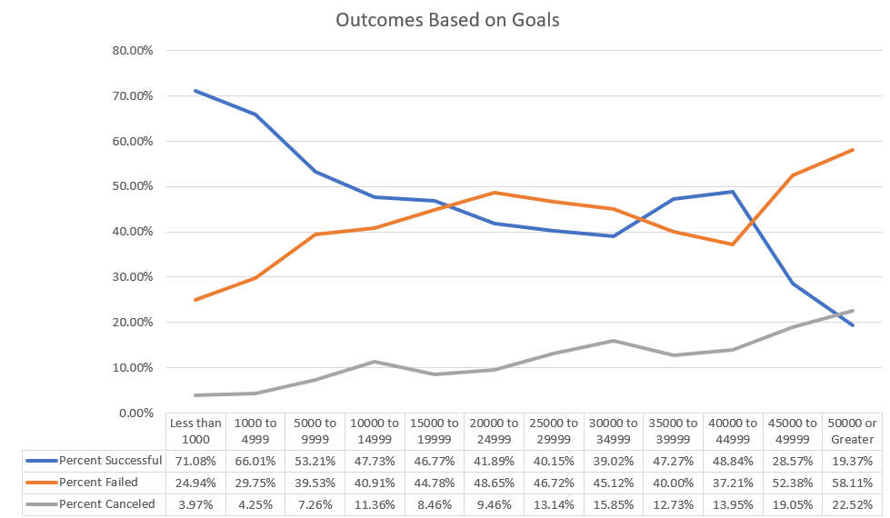

The last chart shows the outcome of the projects based upon goals. This chart is the most telling of all, showing that the most successful outcomes have the smallest goals. Projects with goals of less than $10K have the most success, while projects with goals of $45K or more are under 30% successful.

One limitation of the database is not showing more about the amounts pledged. What is the largest pledge for each project. Or possibly, how many pledges are less or more than a specific dollar amount. This would answer the question of a project being successful due to one or more large pledges.

Another chart or analysis that could be derived from the data would be comparing success rates to Staff Picks. Does this have an influence on what projects people pledged money to? Another analysis could involve the year the project was introduced. Are similar projects more successful now or were they more successful in earlier years?